January | Free Medium Bowl of Hearty Chicken Soup or LTF Chicken Tortilla Soup
February | MYSTERY OFFER
March | Any Size Coca-Cola Beverage or Dasani Bottled Water
April | MYSTERY OFFER
May | 8-count Grilled or Fried Nuggets
June | MYSTERY OFFER
July | Small Hand-Spun Milkshake
August | MYSTERY OFFER
September | MYSTERY OFFER
October | Any Size Coca-Cola Soft Drink or Dasani Bottled Water
November | MYSTERY OFFER
December | YOUR CHOICE: Chick-fil-A Sandwich, Spicy Sandwich or Grilled Sandwich
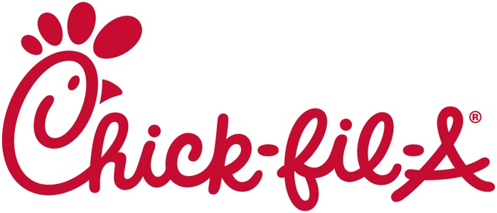

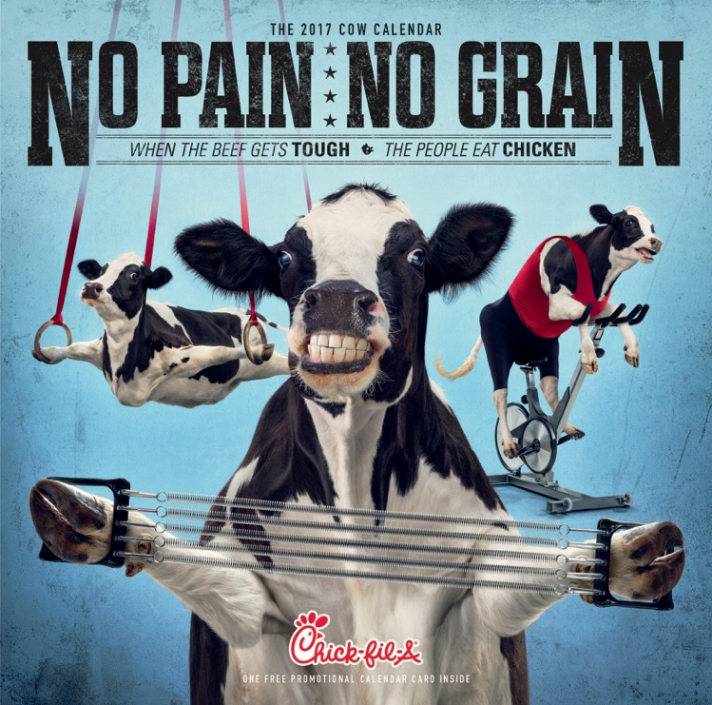

Includes a Digital Offer Card loaded with FREE food each month:

